CC2101 Software Engineering Assignment 2



School of Systems and Technology UMT Lahore Pakistan

NAME: NIMRA FAYSAL
ROLL NO F2024065140
SECTION: W8
SOFTWARE ENGINEERING

List of Actors:

1. ACTORS OF THE SYSTEM

Primary Actors
- User
  - Adds, updates, deletes, and manages contacts.
  - Views lists, filters, sorts, and searches contacts.
- Admin
  - Manages user accounts, permissions, and system activities.

Secondary Actors
- Notification System (External System)
  - Sends alerts for login, updates, reminders, etc.
- Database Server
  - Stores encrypted contact details, logs, and user records.
- External Import/Export Module
  - Handles CSV/Excel import and PDF/CSV export.

2. LIST OF USE CASES (Based on Your Functional Requirements)

User Use Cases
- Register Account
- Login / Logout
- Update Profile
- Add Contact
- Edit Contact
- Delete Contact
- View All Contacts
- Search Contacts
- Sort Contacts
- Add Custom Fields
- Filter Contacts
- Import Contacts
- Export Contacts
- Bulk Actions (Update/Delete multiple contacts)
- Set Contact Reminders

Admin Use Cases
- Manage Users
- Manage Roles & Permissions
- View Activity Logs

System Use Cases
- Validate Input
- Send Notifications
- Encrypt/Decrypt Data
- Maintain Change Log

3. USE CASE SPECIFICATIONS:

Field | Description
Use Case Name | Register User
Use Case ID | UC01
Primary Actor | User
Secondary Actors | Database Server
Preconditions | User has a valid email & strong password
Postconditions | User account created successfully
Main Flow | 1. User opens registration form2. Enters email & password3. System validates inputs4. System stores encrypted user data5. System sends success confirmation
Alternate Flow | Invalid email → show errorWeak password → ask user to strengthen
Extensions | System logs registration event
Special Requirements | Data encryption (AES-256) must be applied

Table UC02 — Login to System
Field | Description
Use Case ID | UC02
Primary Actor | User
Secondary Actors | Notification System
Preconditions | User must be registered
Postconditions | User logged into dashboard
Main Flow | User enters email/password → system authenticates → MFA (if enabled) → dashboard opens
Alternate Flows | Incorrect password → error shown
Extensions | System sends login notification
Special Requirements | Response time <3 seconds

Table UC04 — Add New Contact
Field | Description
Use Case ID | UC04
Primary Actor | User
Secondary Actors | Database Server
Preconditions | User is logged in
Postconditions | New contact saved
Main Flow | 1. User selects “Add Contact” 2. Enters name, phone, email, etc. 3. (Optional) Adds custom fields 4. System validates input 5. System encrypts and stores data
Alternate Flows | Invalid phone/email → show message
Extensions | Log entry created for auditing

Table UC05 — Edit Contact
Field | Description
Use Case ID | UC05
Primary Actor | User
Secondary Actors | Database Server
Preconditions | Contact exists
Postconditions | Contact updated
Main Flow | User opens contact → edits fields → system validates → saves updated version
Extensions | Change recorded in activity log

Table UC09 — Search Contacts
Field | Description
Use Case ID | UC09
Primary Actor | User
Preconditions | At least one contact in database
Postconditions | Search results displayed
Main Flow | User enters search term → system filters matching results
Alternate Flow | No match found → system shows “No records found”

Table UC12 — Import Contacts

Field | Description
Use Case ID | UC12
Primary Actor | User
Secondary Actors | External Import Module
Preconditions | Valid file (CSV/Excel)
Postconditions | Contacts imported
Main Flow | User uploads file → system validates → imports valid entries
Alternate Flow | Invalid file format → error message

Table UC17 — Manage Users (Admin)

Table UC17 — Manage Users (Admin)
Field | Description
Use Case ID | UC17
Primary Actor | Admin
Secondary Actors | Database Server
Preconditions | Admin logged in
Postconditions | User accounts updated
Main Flow | Admin views list → updates roles, permissions, status
Extensions | Activity log updated

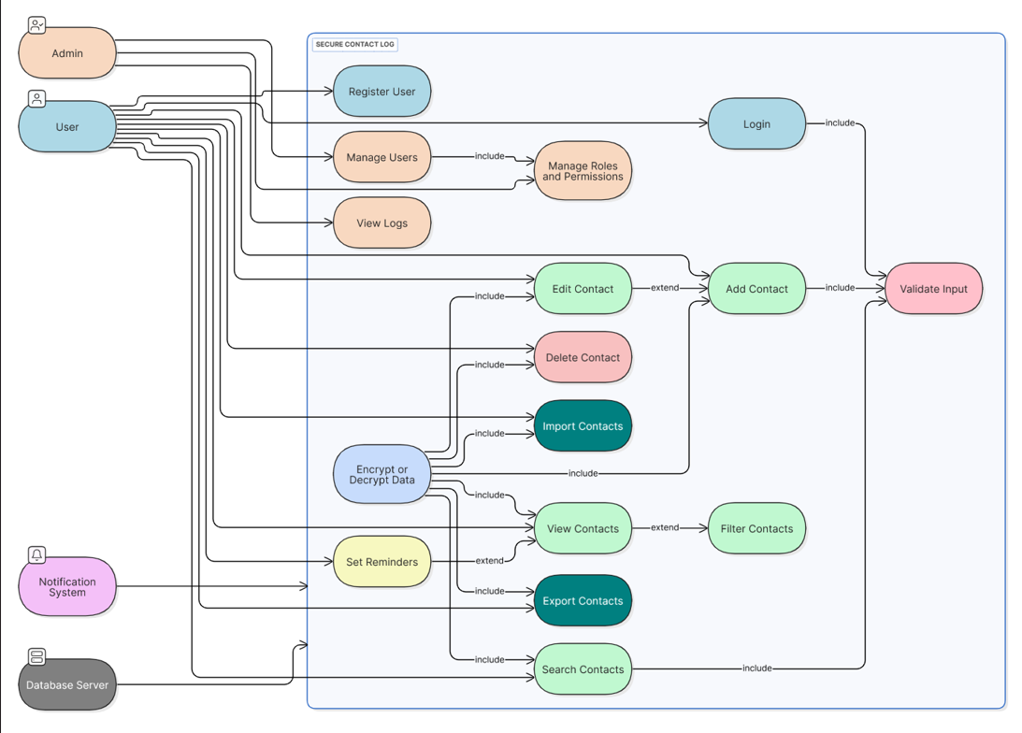

User > Register User
User > Login
User > Add Contact
User > Edit Contact
User > Delete Contact
User > View Contacts
User > Search Contacts
User > Import Contacts
User > Export Contacts
User > Set Reminders

Admin > Manage Users
Admin > Manage Roles and Permissions
Admin > View Logs

// Relationships: Use case includes and extends
Login > Validate Input: <<include>>
Add Contact > Validate Input: <<include>>
Search Contacts > Validate Input: <<include>>

Edit Contact > Add Contact: <<extend>>
View Contacts > Filter Contacts: <<extend>>
Set Reminders > View Contacts: <<extend>>

Manage Users > Manage Roles and Permissions: <<include>>

// Security: Encryption applies to all data operations
Encrypt or Decrypt Data > Add Contact: <<include>>
Encrypt or Decrypt Data > Edit Contact: <<include>>
Encrypt or Decrypt Data > Delete Contact: <<include>>
Encrypt or Decrypt Data > View Contacts: <<include>>
Encrypt or Decrypt Data > Search Contacts: <<include>>
Encrypt or Decrypt Data > Import Contacts: <<include>>
Encrypt or Decrypt Data > Export Contacts: <<include>>

// External systems
Notification System > Secure Contact Log
Database Server > Secure Contact Log

